[](http://www.wpclipart.com/computer/game_control/game_controller_dated.png.html) [](http://www.wpclipart.com/computer/disks/CD/CD_DVD.png.html) [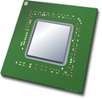](http://www.wpclipart.com/computer/hardware/CPU/index.html) [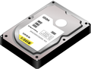](http://www.wpclipart.com/computer/hardware/drives/hard_drives/hard_drive.png.html)

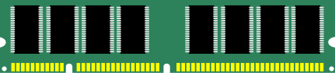

[](http://www.wpclipart.com/computer/hardware/drives/hard_drives/hard_drive_open.png.html) [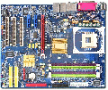](http://www.wpclipart.com/computer/hardware/motherboard/index.html) [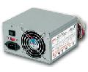](http://www.wpclipart.com/computer/hardware/power_supply.png.html)

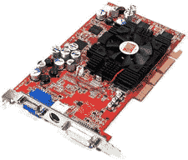 [computer mouse](http://www.wpclipart.com/computer/mouse/computer_mouse.png.html) [](http://www.wpclipart.com/computer/PCs/PC_tower.png.html)

[](http://www.wpclipart.com/computer/printer/inkjet_printer.png.html) [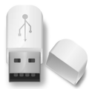](http://www.wpclipart.com/computer/USB_stick/flash_drive_gray_toned.png.html)

[](http://www.wpclipart.com/computer/hardware/monitors/more_LCD/LCD_desktop.png.html) [](http://www.wpclipart.com/computer/hardware/keyboard/index.html)

